**Case Study : VPC**

Set the respective CIDRs, and give no preference on AZs in which VPC have to be created.

Creating the five subnets according to the 4-tier architecture suggested for the Production Network:

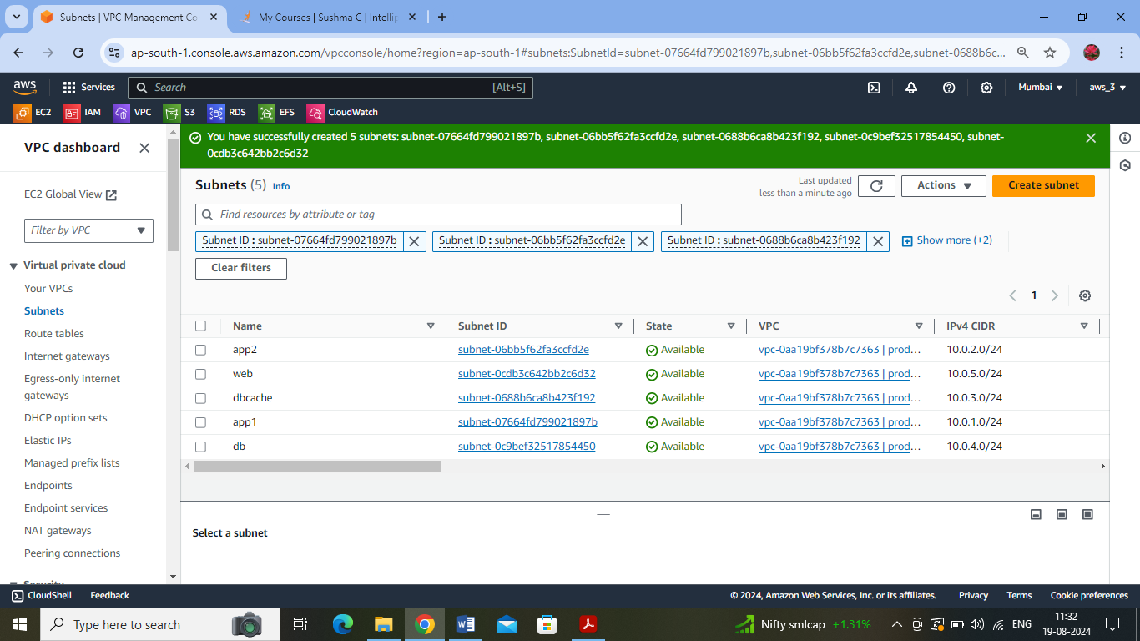

Assigning public ip address for the web subnet:

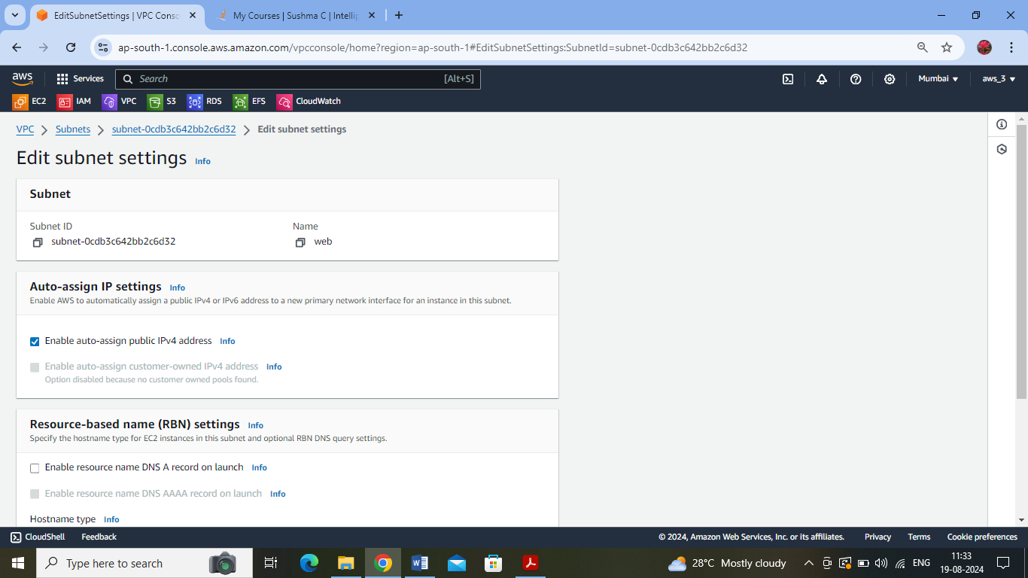

Created the IGW for the Production network :

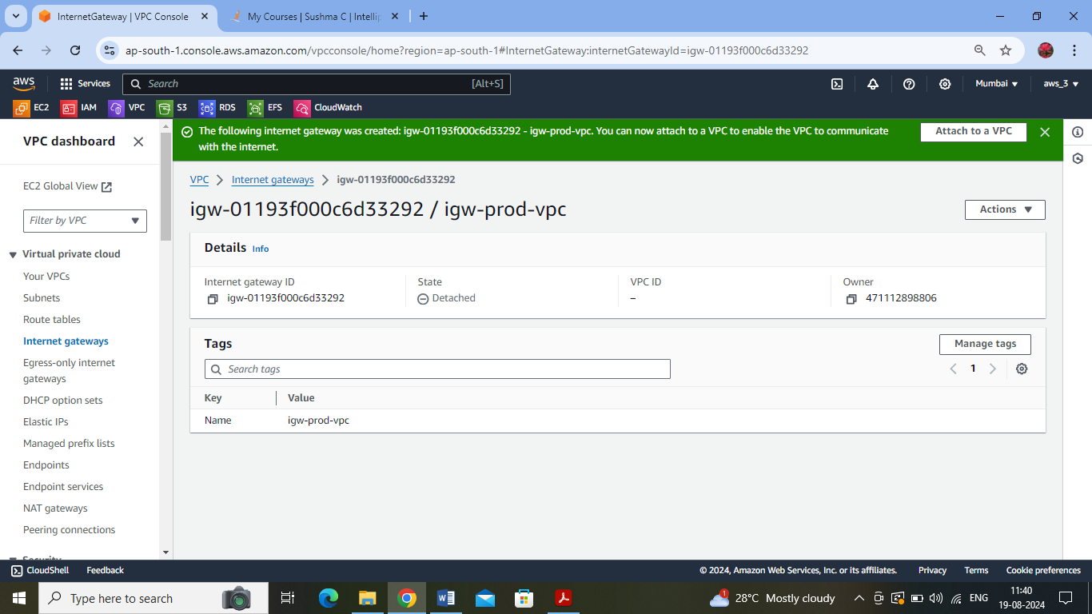

Attaching the IGW to the Production VPC:

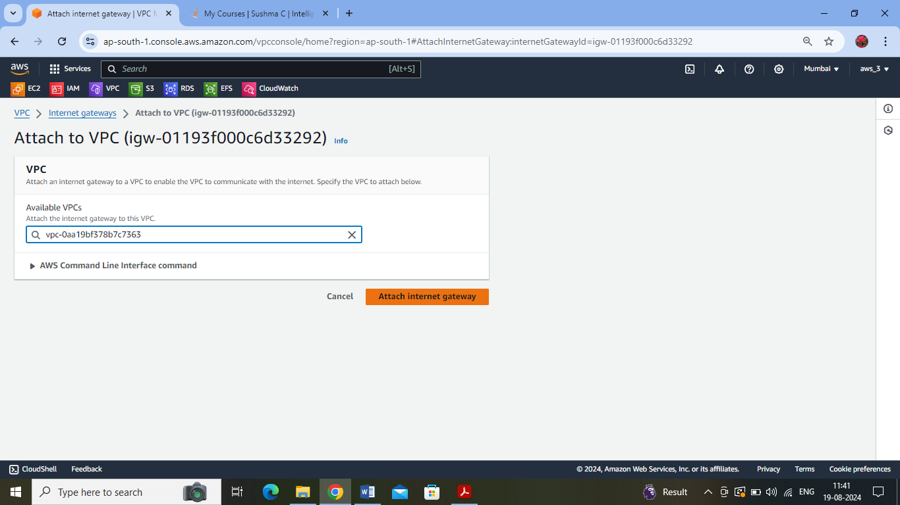

Adding the route to the Internet: destination 0.0.0.0/0 and target as the above created IGW:

Creating a subnet association between the web-subnet and the route table:

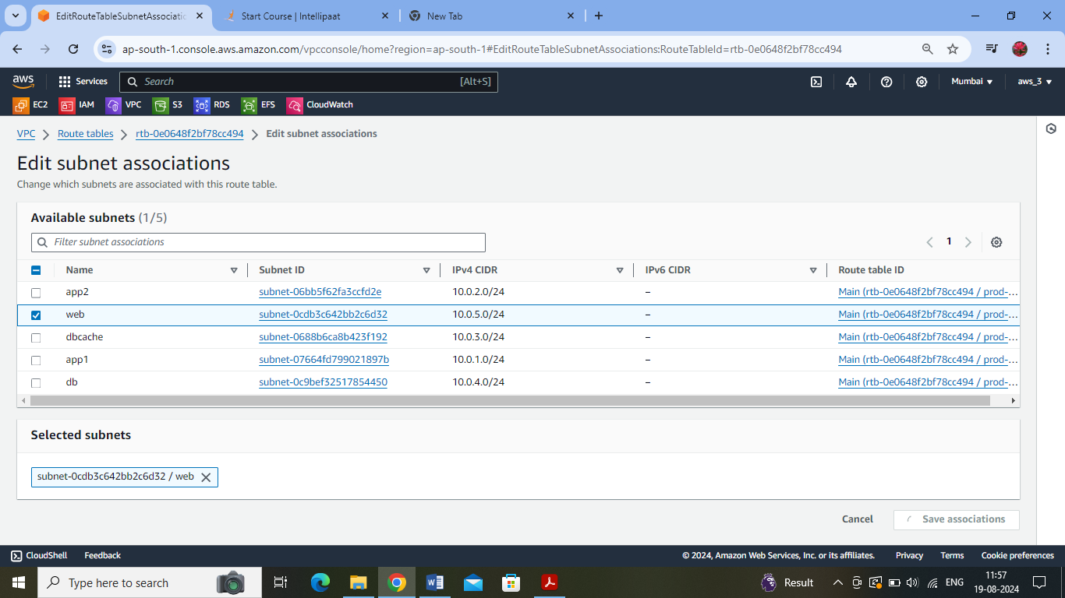

Creating a new route table (although a default route table is automatically created for our given vpc):

Added the route to the internet by attaching igw.

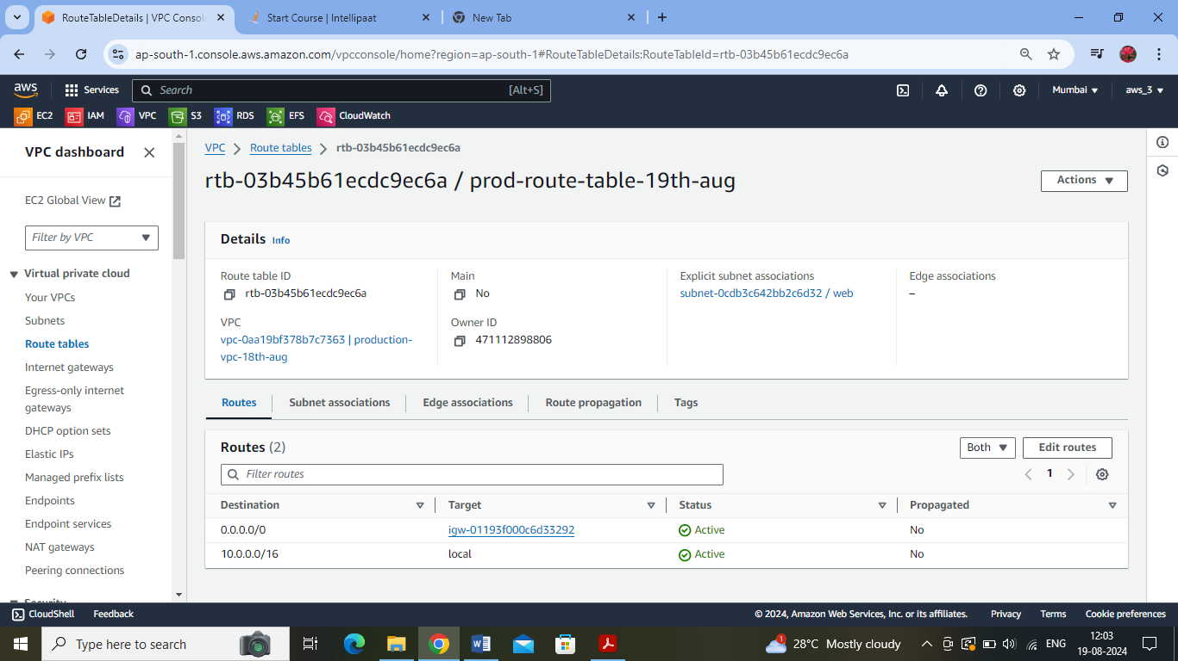

Associated this route table with the specific web subnet (as it is the only public subnet) :

Creating the NAT gateway :

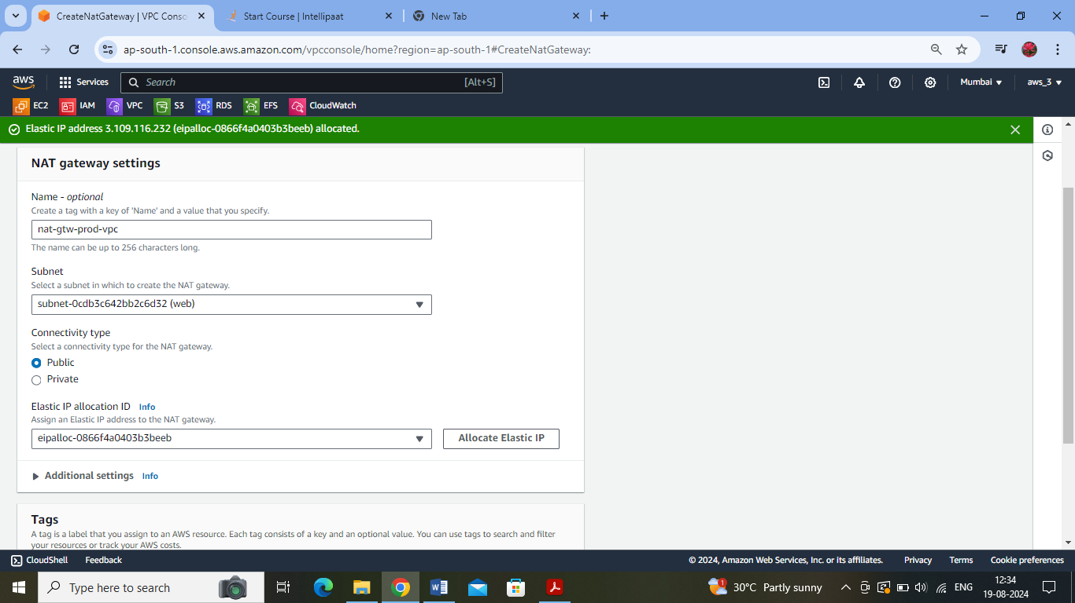

Creating a RT to associate the NAT gateway:

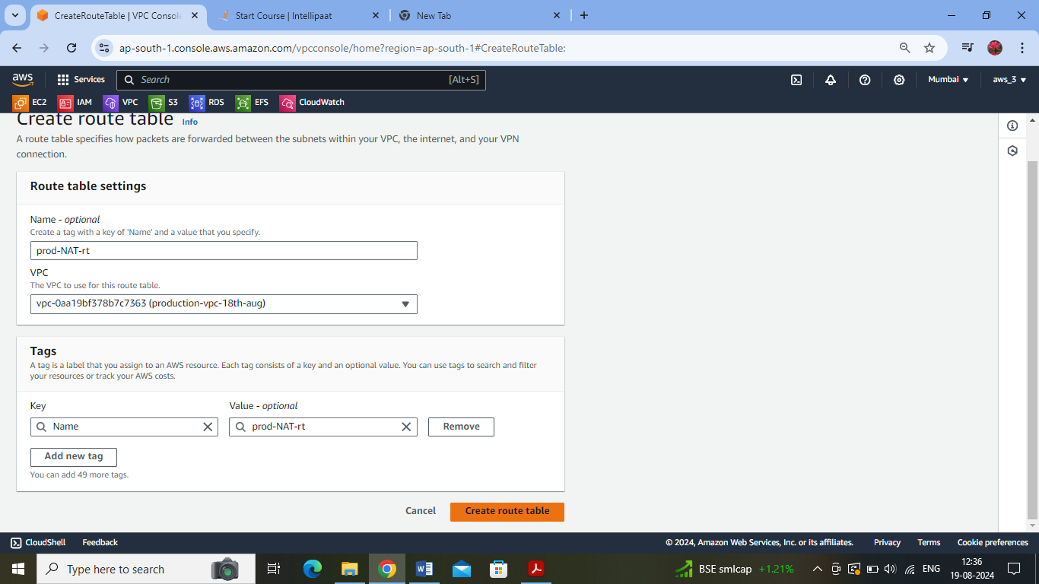

Added the destination of internet with target as NAT :

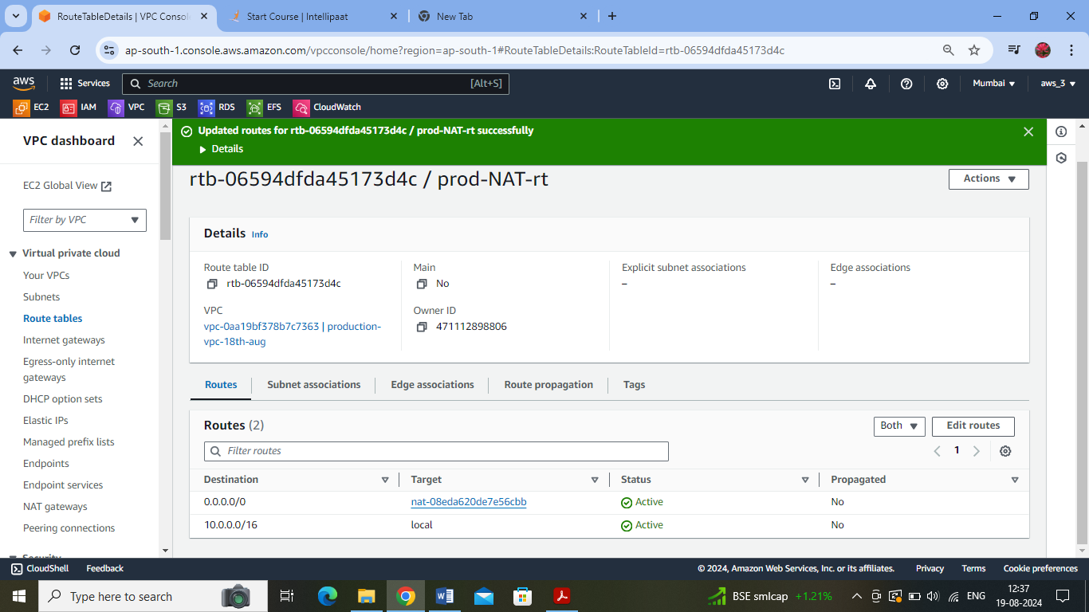

Associated the subnets app1 and dbcache to the RT:

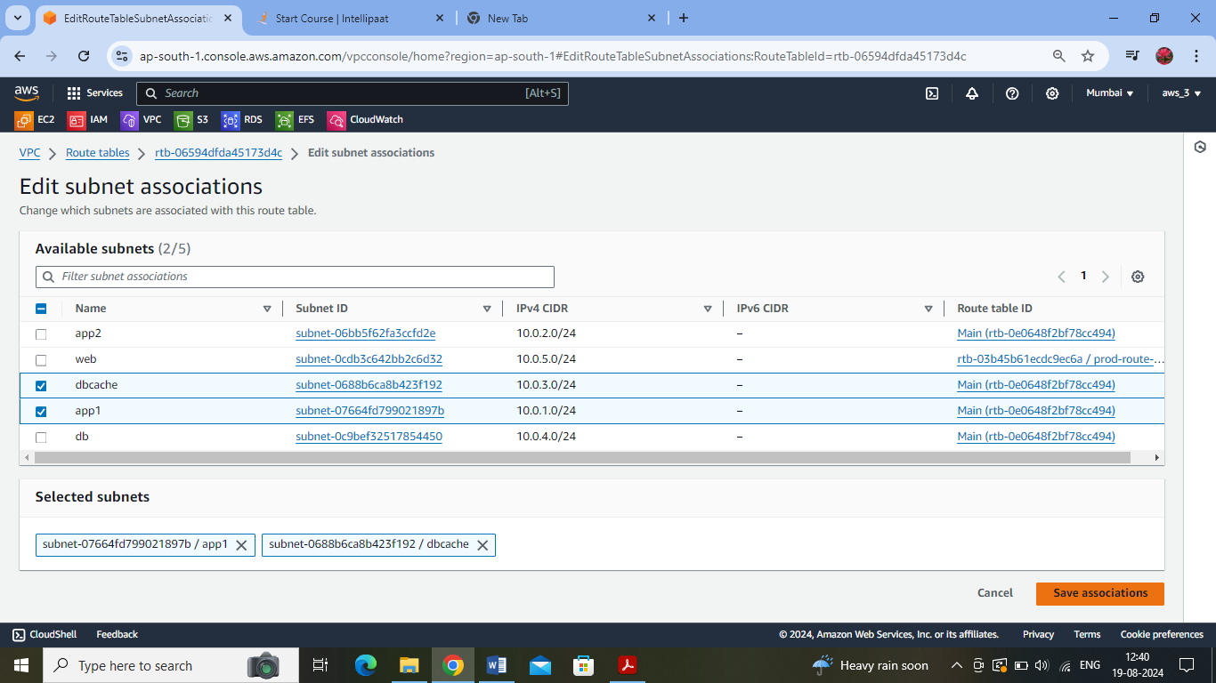

Created the 2-tier architecture of the Dev Network :

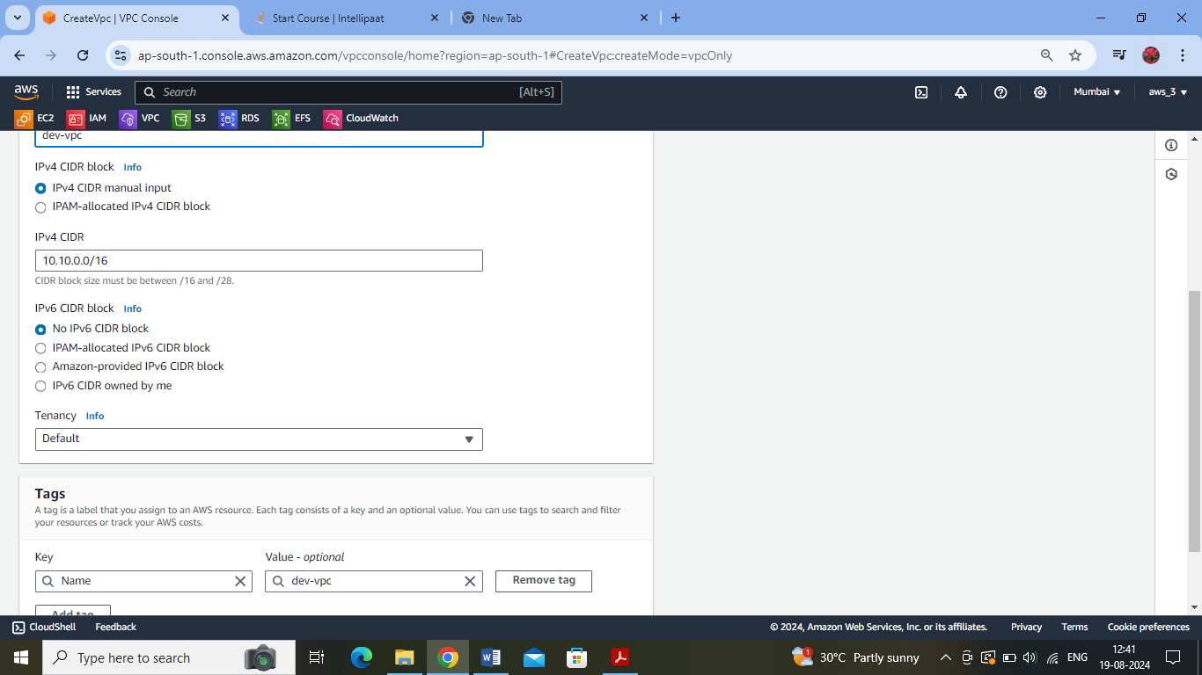

Db and web subnets

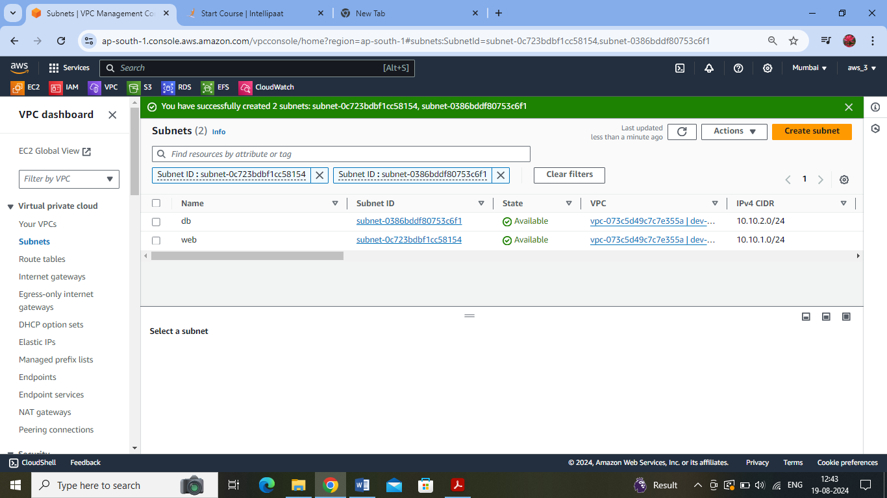

Web subnet is made a public subnet :

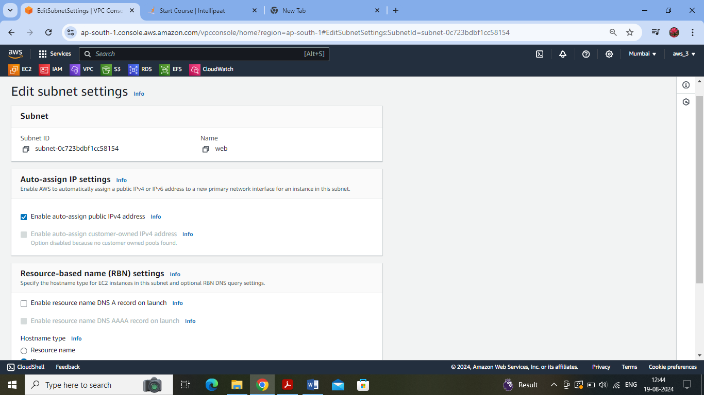

Created the respective instances in the respective subnets of each VPC :

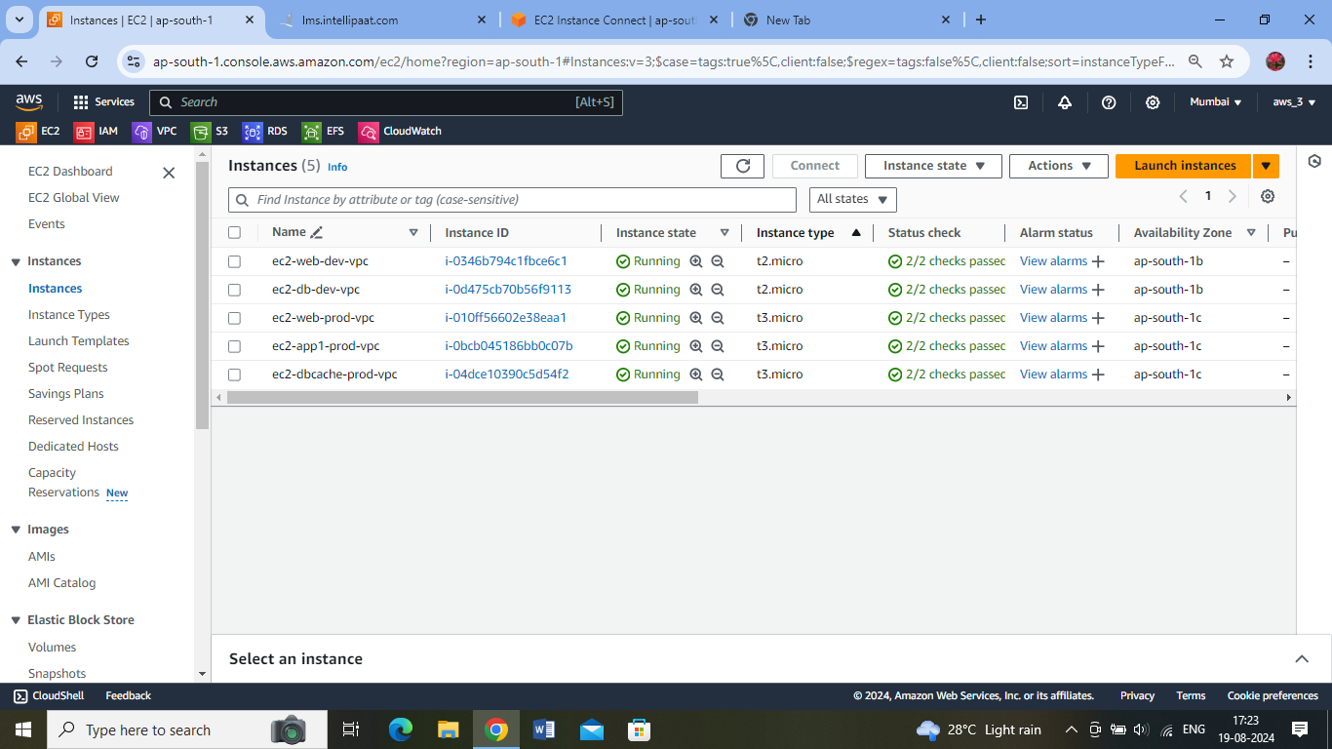

Connecting to ec2 instance – in web-prod-vpc : Able to access internet from web subnet of production network:

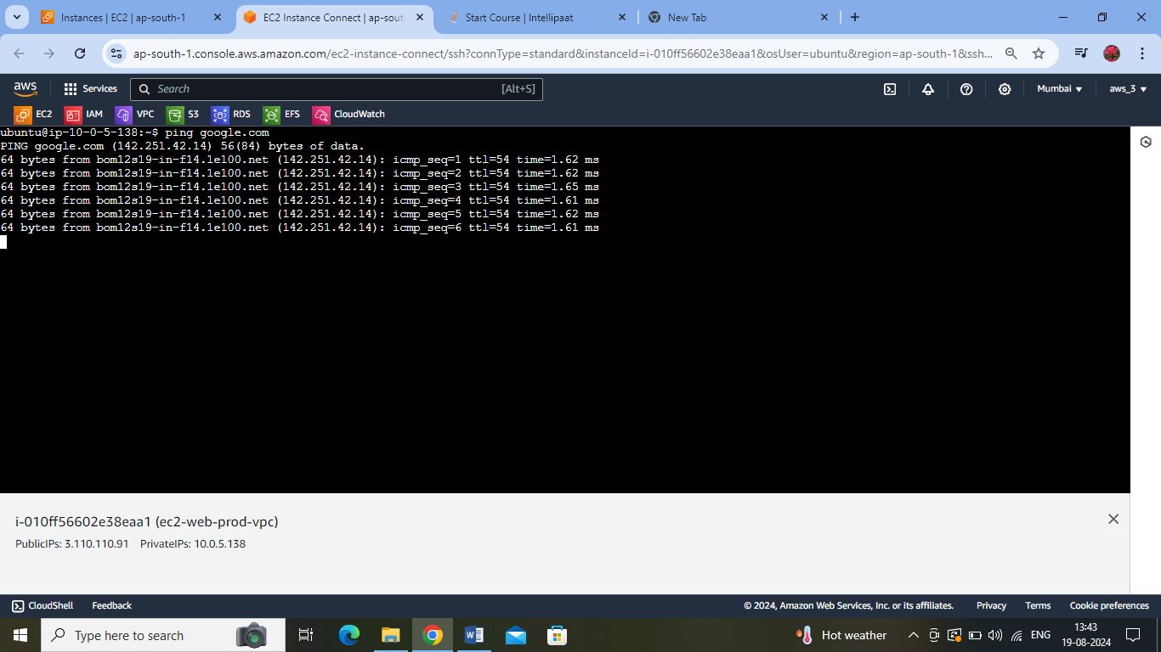

Logged into EC2 on app1 subnet using the Ec2 instance on web subnet:

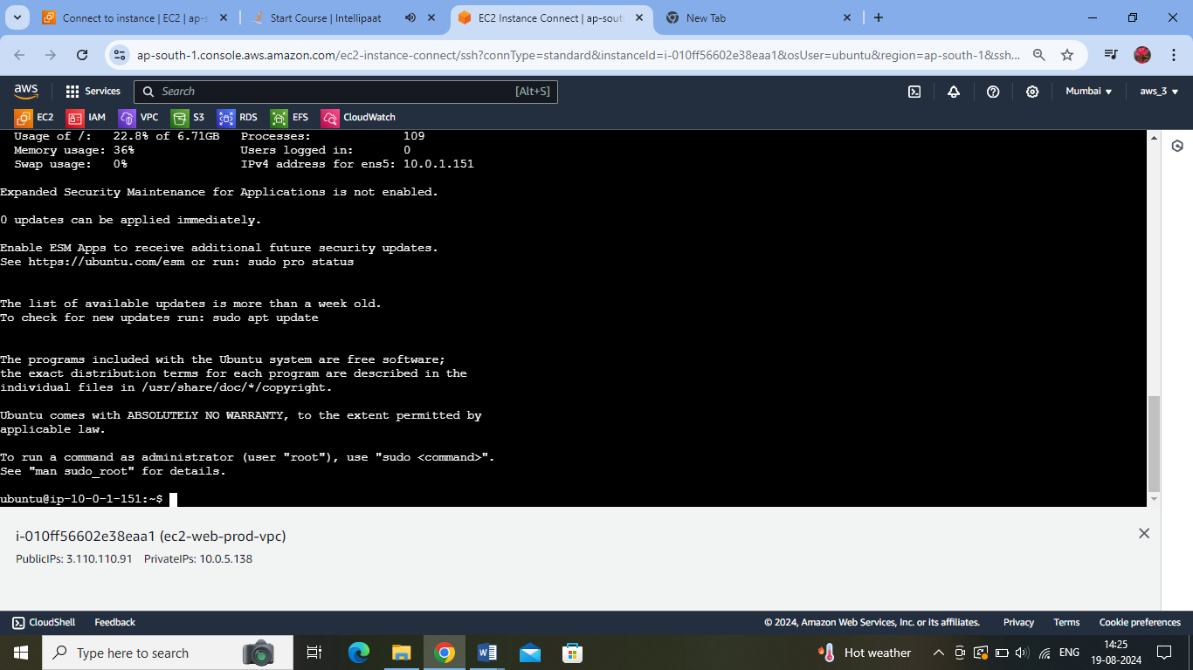

Able to access google from here as well. Hence the private subnet is able to access the internet via NAT gateway.

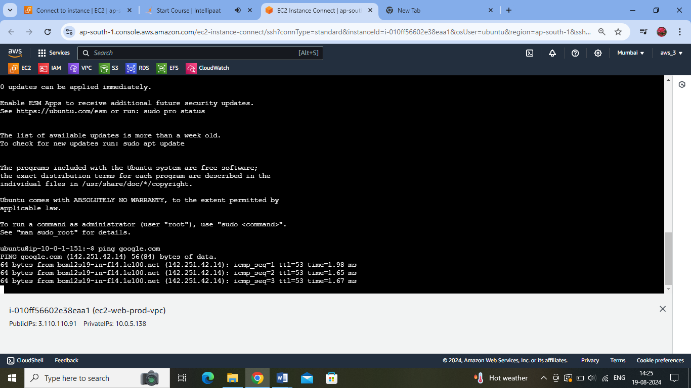

Created a Peering Connection between both the VPCs :

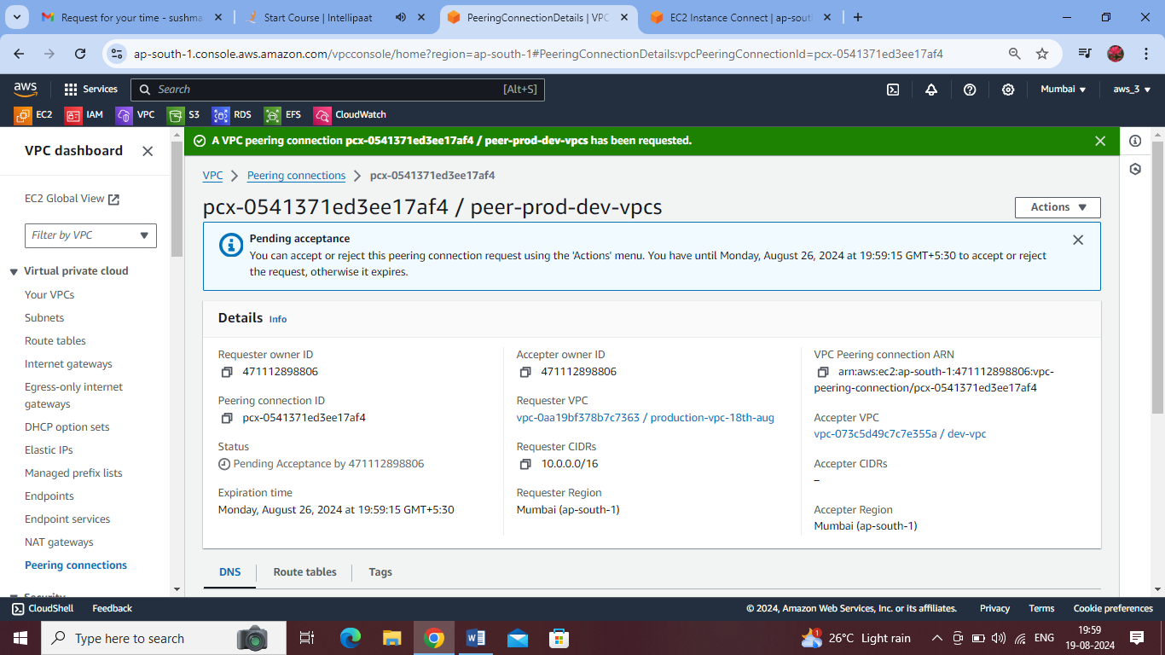

Accepted the Peering Connection:

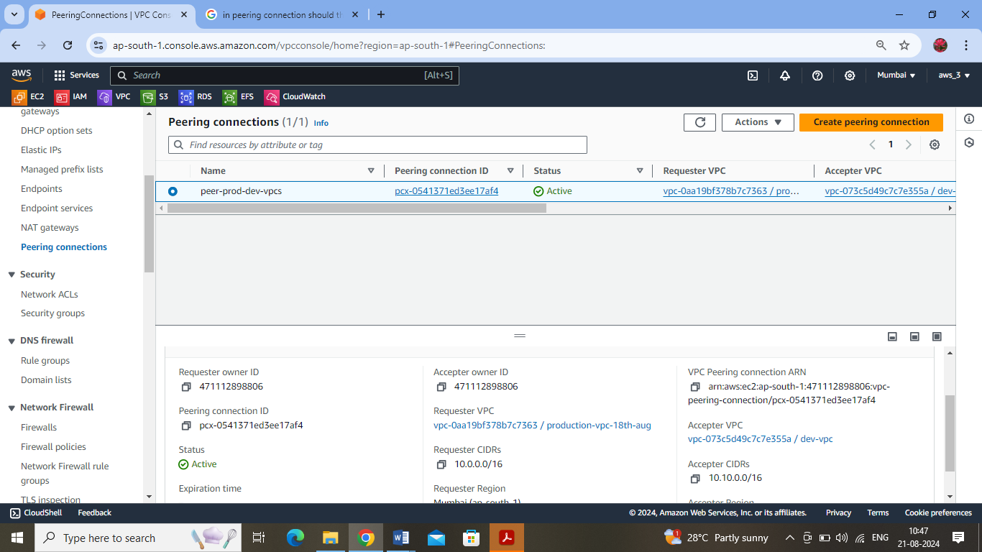

RT-1: Added the route for the peering connection – from prod vpc to dev vpc :

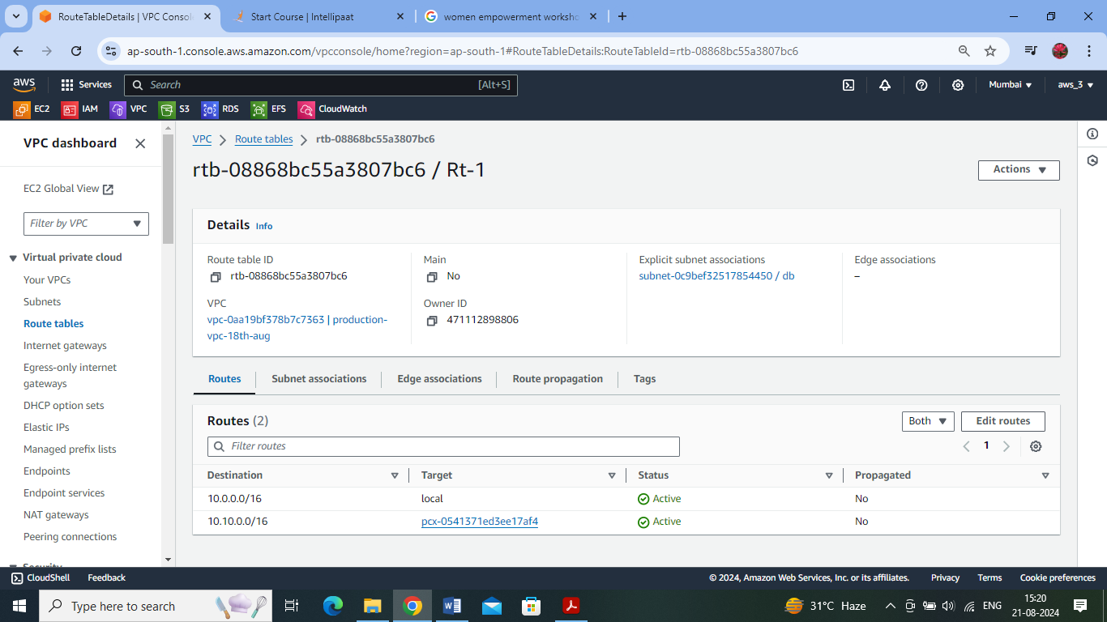

Associated the db subnet of prod vpc with RT-1

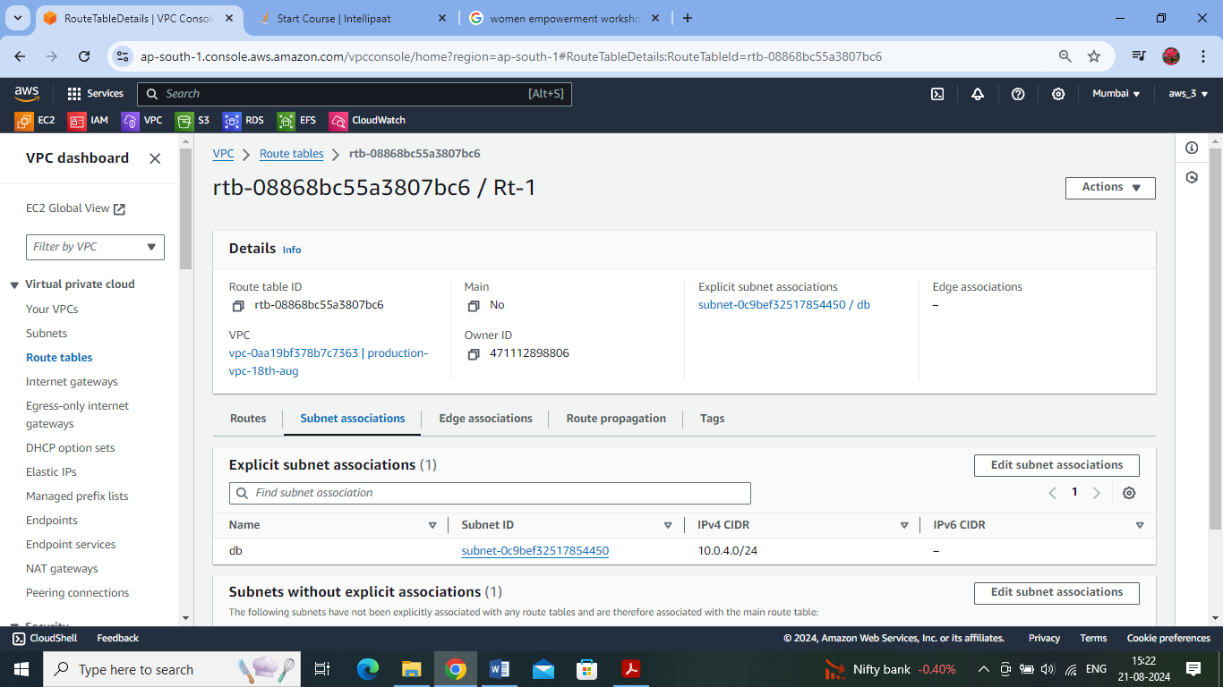

RT-2 : Added the route for the peering connection – from dev vpc to prod vpc :

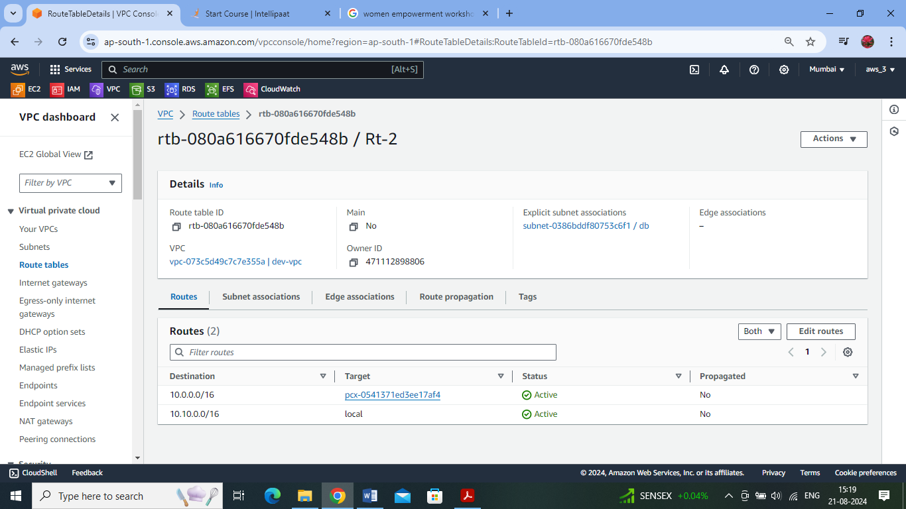

Db subnet of dev-vpc is associated with Rt-2 :

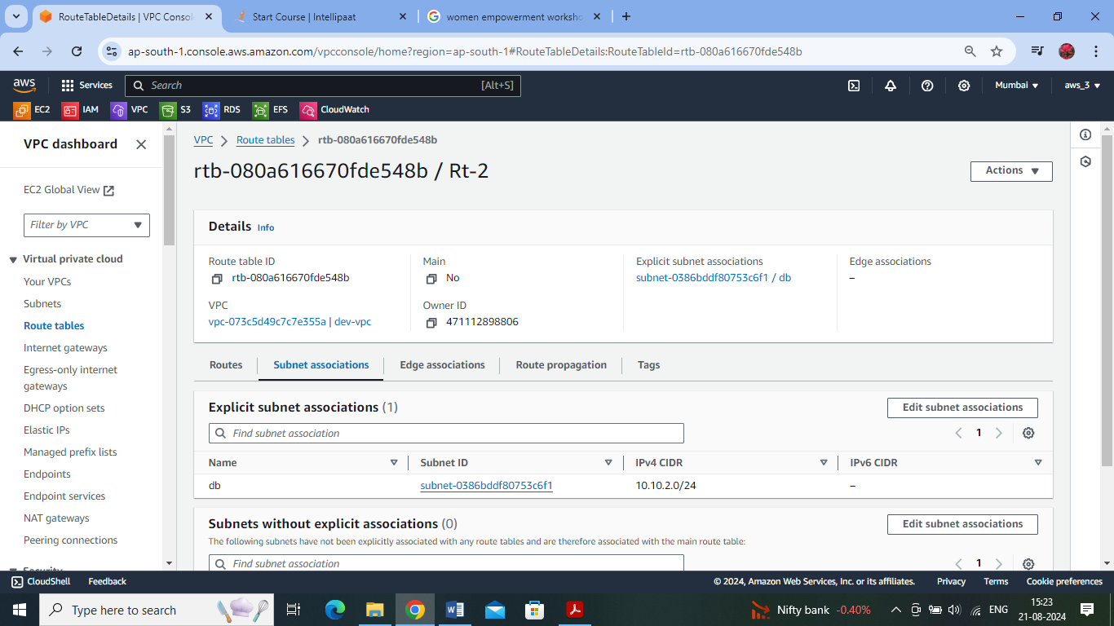

Final – Resource map of Production VPC :

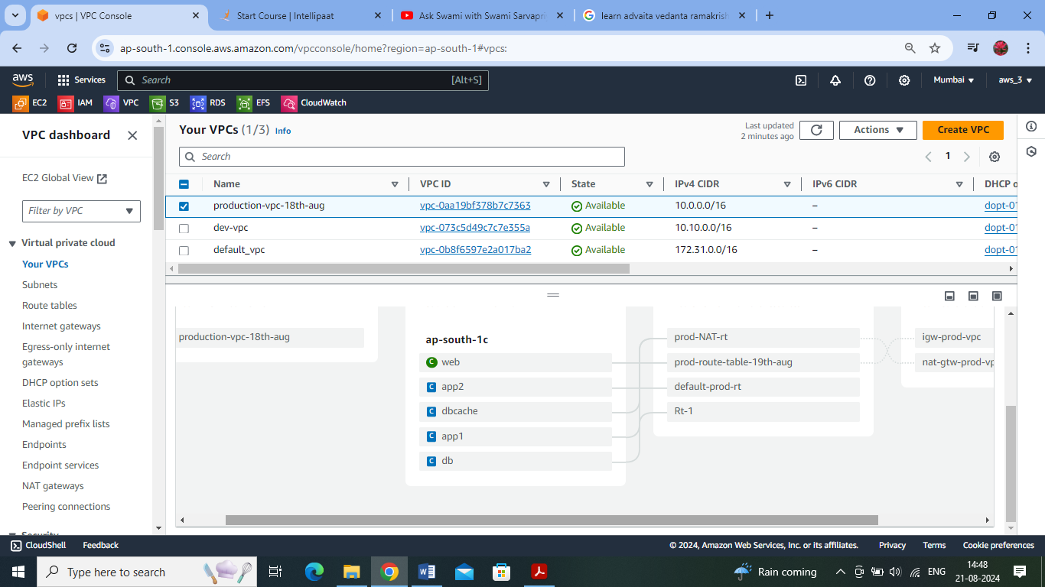

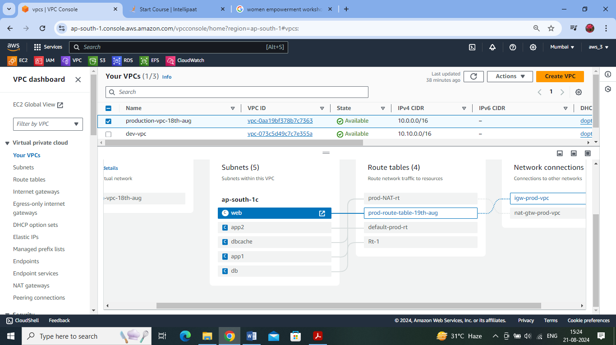

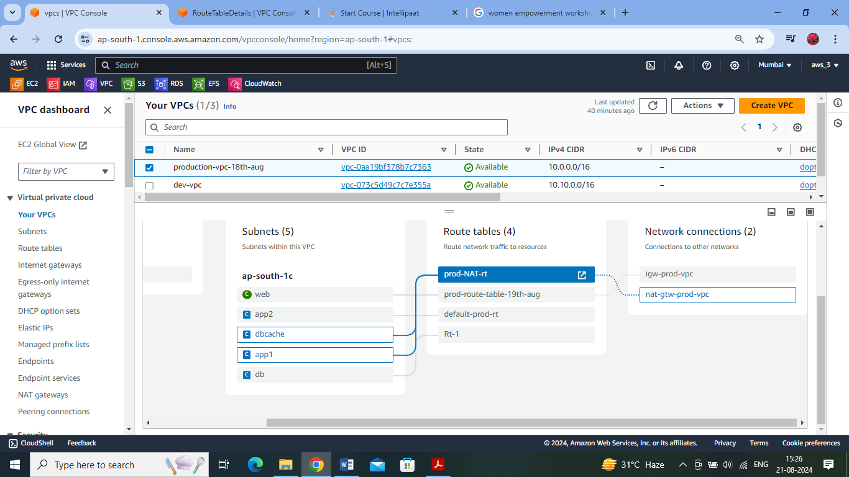

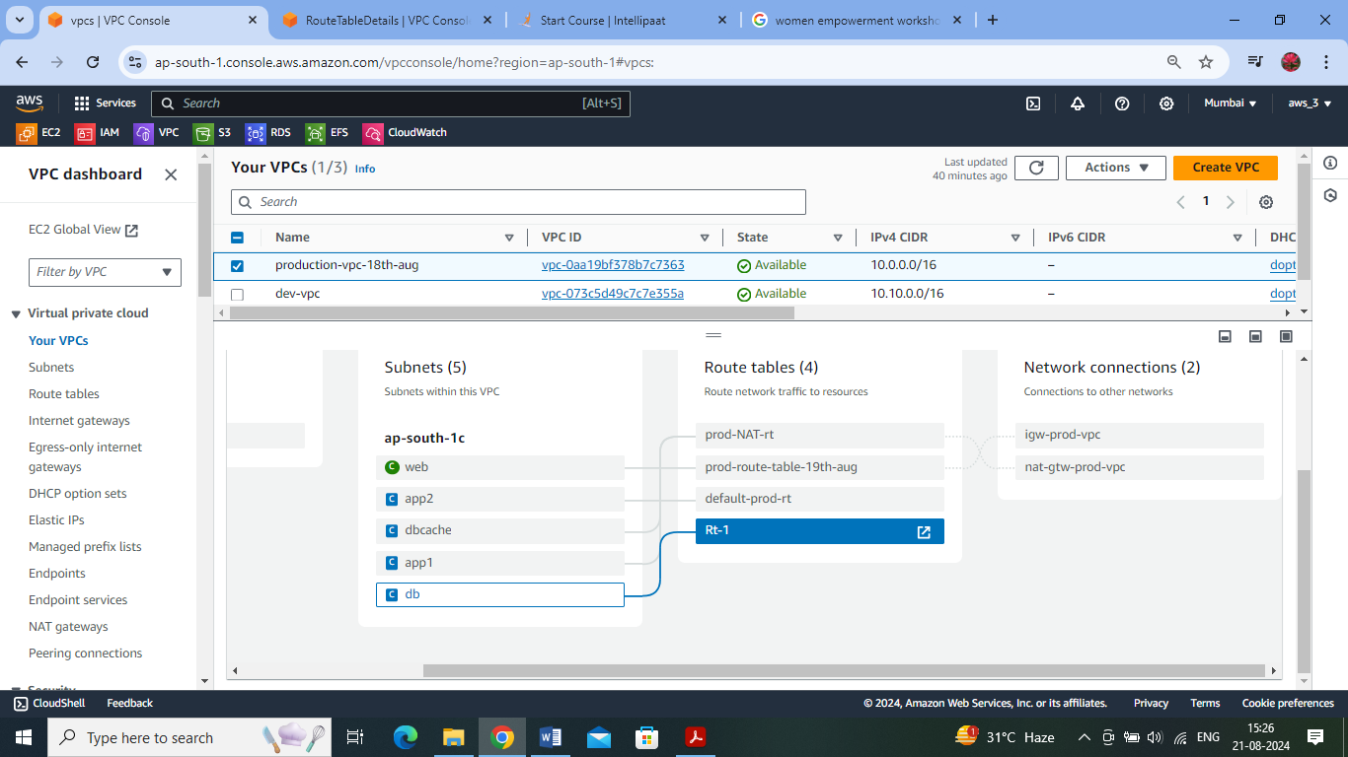

Final development vpc- resource map:

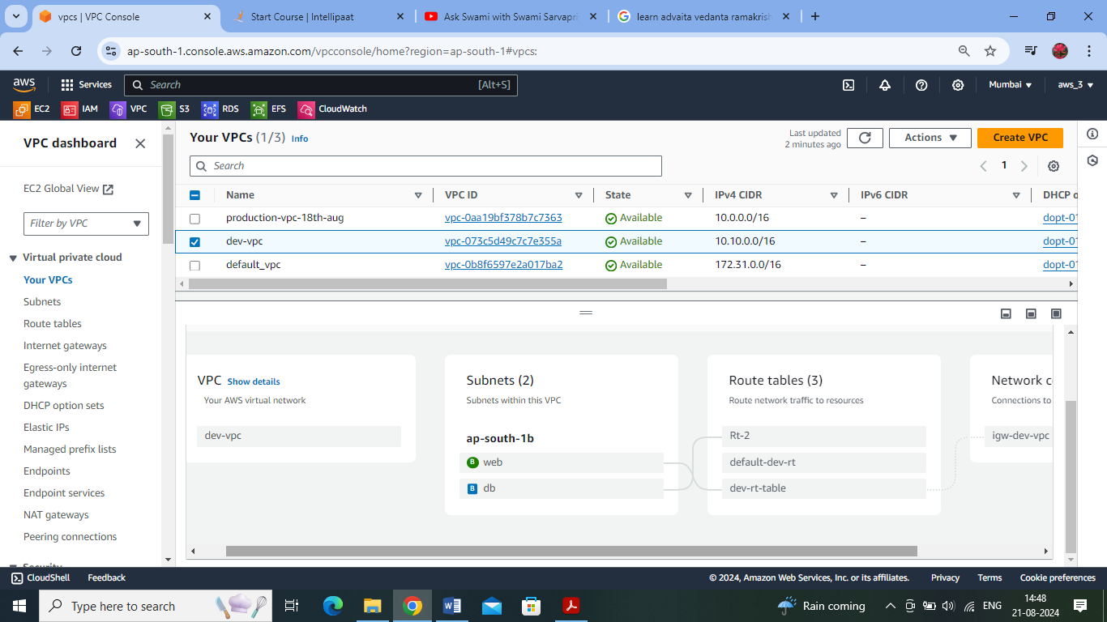

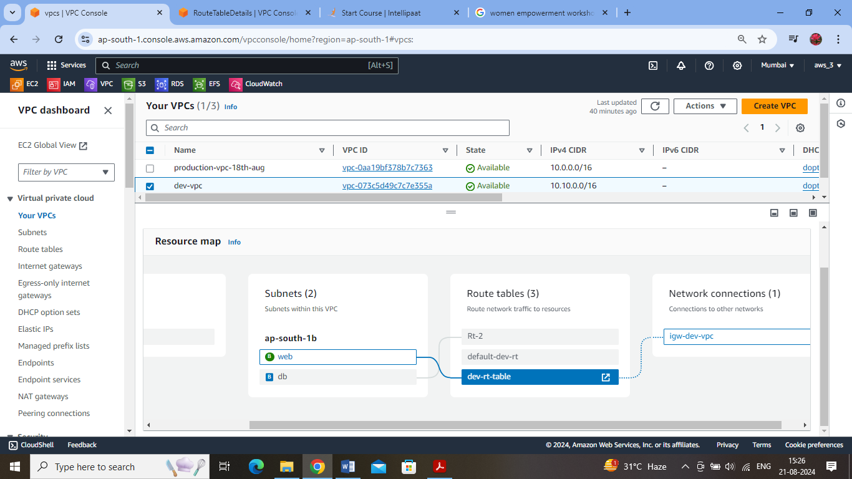

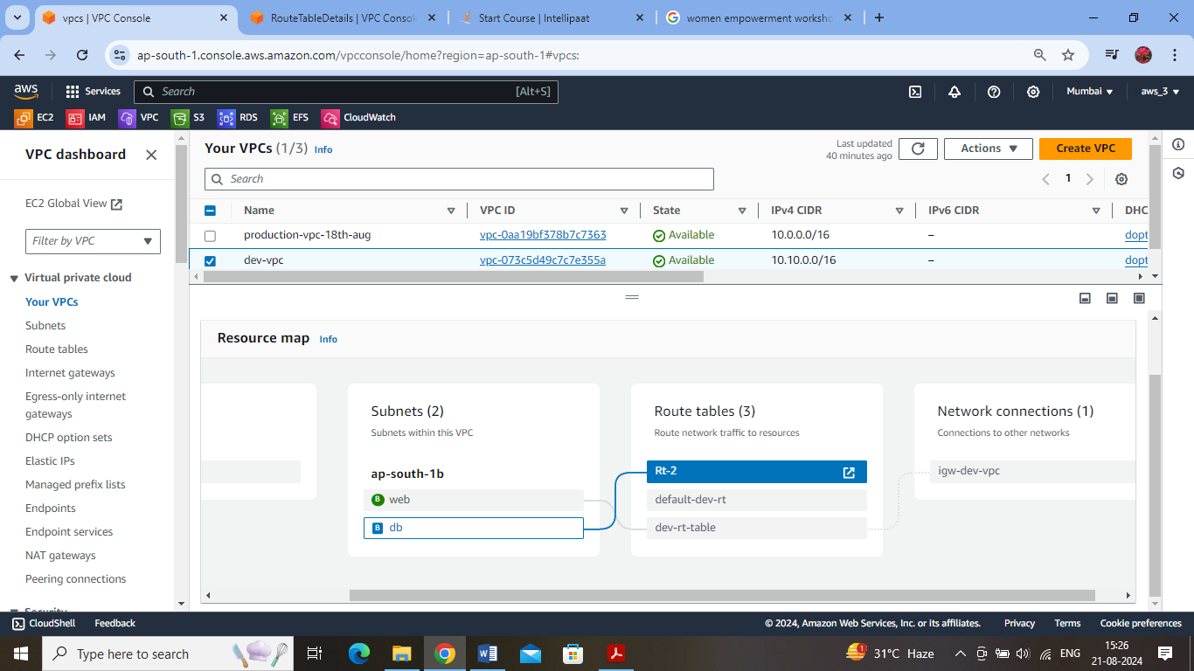

Connecting to the EC2 instance in db subnet (prod vpc) via the web subnet (prod vpc)

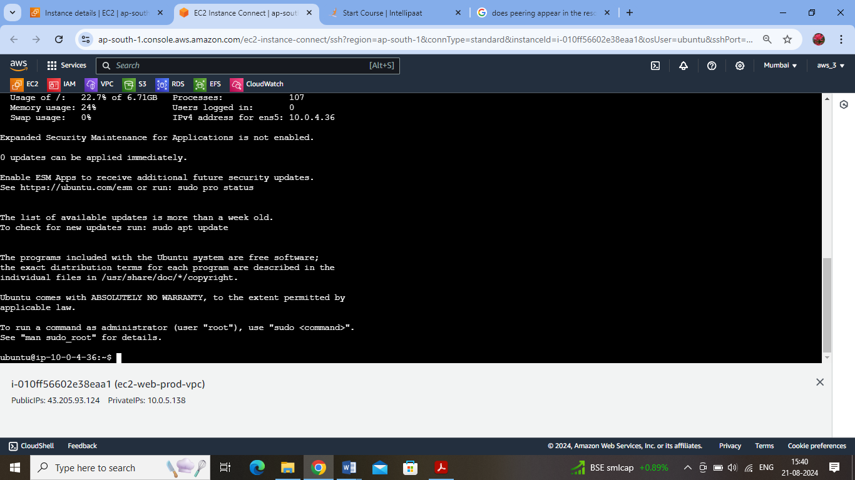

Connecting to the db subnet (dev-vpc) from the db subnet (prod vpc) using ssh :

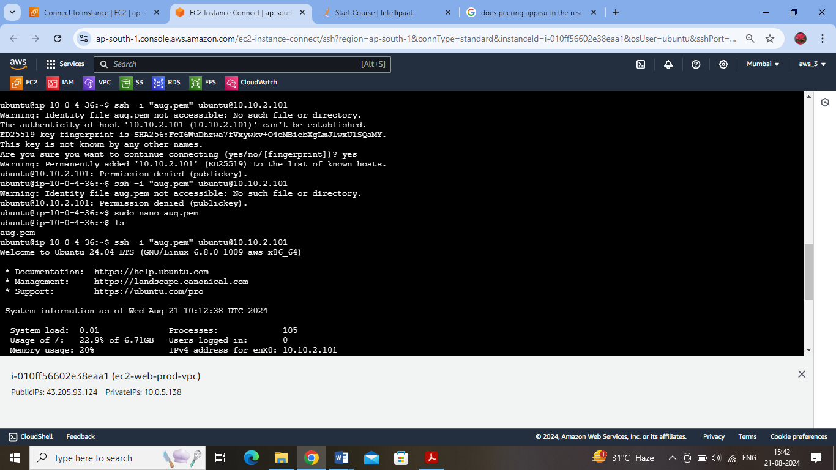

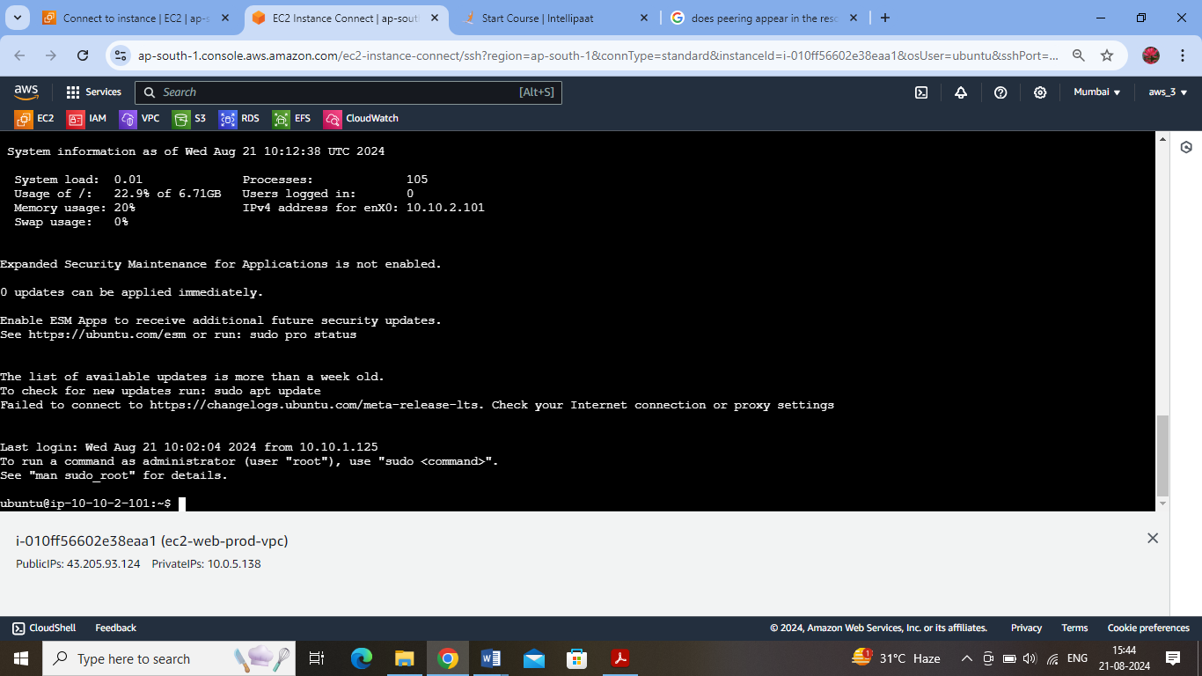

Hence the peering connection works from prod vpc -> dev vpc

Checking the vice versa :

Logged into to db subnet (dev vpc) from web subnet (dev vpc):

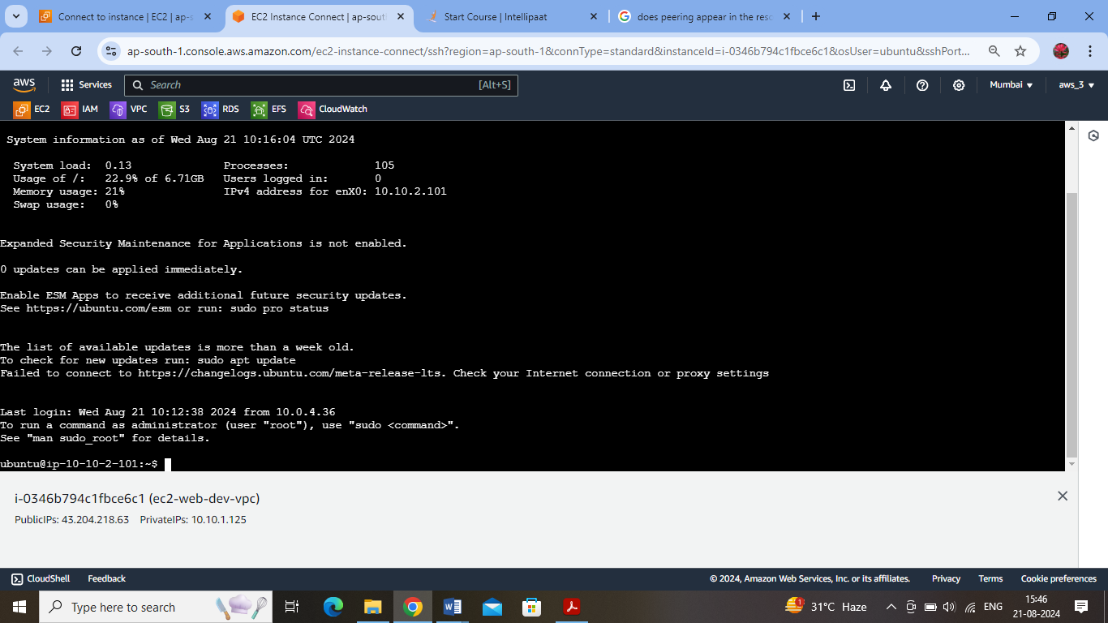

Logged into to db subnet (prod vpc) from db subnet of (dev vpc):

